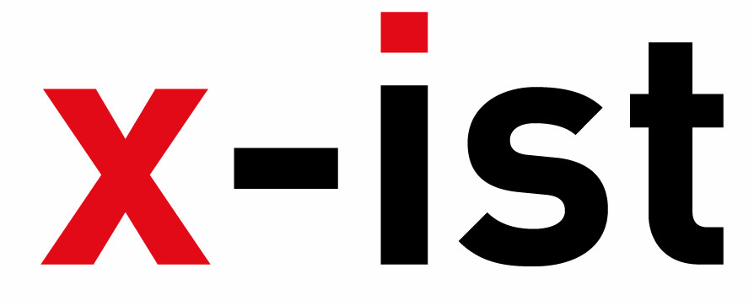 | Abdi İpekçi Caddesi Kaşıkçıoğlu Apt. No:42 D:2 34365 Nişantaşı İstanbul  www.artxist.com  info@artxist.com  T. +90 212 291 77 84 F. +90 212 343 69 35 | PRESS RELEASE

“Save Me With Your Fire”

Ali Elmacı depicts the modern history of social problems without restraint
when it comes to using irony and sarcasm. The aspects of family, society, state, media and sacred values,
which are invisible to the naked eye are conveyed through the scenarios and characters that he builds.
Ali Elmacı was introduced by x-ist for the first time in 2011 with his show “Inheritance Passes From Father To Son”
which criticized the society through portraits. Ali Elmacı’s second solo exhibition “Save Me With Your Fire”
runs from 18th October to 17th November 2012 once again at x-ist.

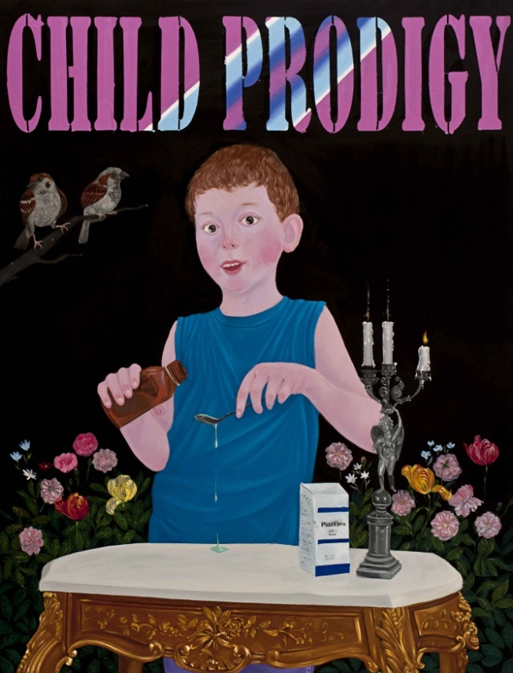

Ali Elmacı, Tell Me Sweet Lies II, Oil on canvas, 130 x 100 cm, 2012

Ali Elmacı’s paintings are, in fact, caricaturized versions of the society’s most hidden stereotypes. “Save Me With Your Fire” is made up of the direct reflections of current affairs. Today’s Turkey is tackled within the State, individual and media triangle in the eyes of the artist. While even the title of the exhibition is a reference to recurrent stereotypes, the insubstantiality of these stereotypes are highlighted through the recurrent camouflage pattern.

The main issue at the heart of the exhibition (and the society) is the individual’s unquestioning obedience vis-à-vis the institution. This paranoia fed with mistrust must be supported by the media in order to maintain the state of fear. The series entitled “Tell Me Sweet Lies / Teach Me Nice Things” questions the difference between real occurrences and their camouflaged accounts in the media. A society that obeys without criticizing and destroys those who criticize can be manipulated as such as a result of its loyalty to an institution, formed in search of a greater power.

“Save Me With Your Fire” will be followed by a second solo exhibition by Ali Elmacı at Lawrie-Shabibi Gallery, Dubai in 2013.

Ali Elmacı
Sinop, 1976

Elmacı graduated from Mimar Sinan Fine Arts Faculty, Painting Department in 2010. He had his first solo show, titled “Inheritance Passes From Father to Son” at x-ist in 2011. He also took place in several group exhibitions since 2007. Among the exhibitions and fairs Elmacı participated are “Art Against Invasion” (Karşı Sanat, 2007), “My Name is Casper” (Old Sümerbank Building, 2009), Contemporary Istanbul’10 & 11, “Genç Ustalar, Usta Gençler” (MKM, 2010), Art Beat 2011, Art Dubai 2012 and Scope Basel 2012.

